**Exercise 4: Creating and Configuring a Maven Project**

**Scenario:**

**You need to set up a new Maven project for the library management application and add Spring dependencies.**

**Steps:**

**1. Create a New Maven Project:**

**o Create a new Maven project named LibraryManagement.**

**Ans.**

Step 1: - Go to File > New > Other...

Step 2: -Select Maven > Maven Project and click Next.

Step 3: -Select Create a simple project (skip archetype selection) and click Next.

Step 4: -Enter the Group Id as com.library and Artifact Id as LibraryManagement1.

Step 5: -Click Finish.

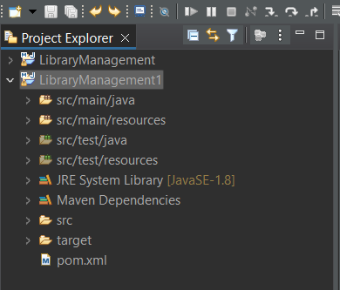

**2. Add Spring Dependencies in pom.xml:**

**o Include dependencies for Spring Context, Spring AOP, and Spring WebMVC.**

**Ans.**

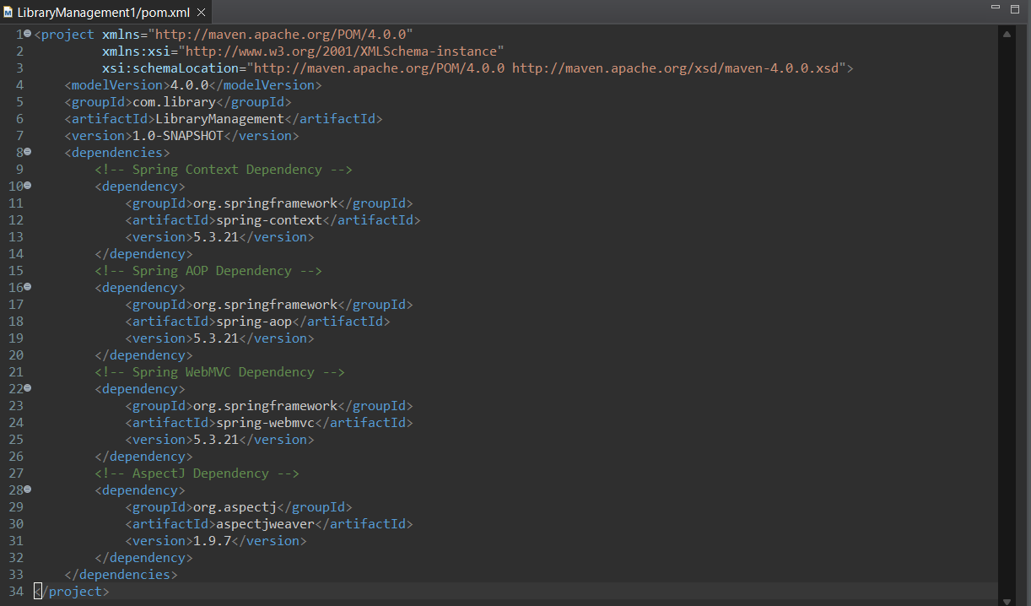

**3. Configure Maven Plugins:**

**o Configure the Maven Compiler Plugin for Java version 1.8 in the pom.xml file.**

**Ans.**

